**AWS:**

1. **AWS login screen**

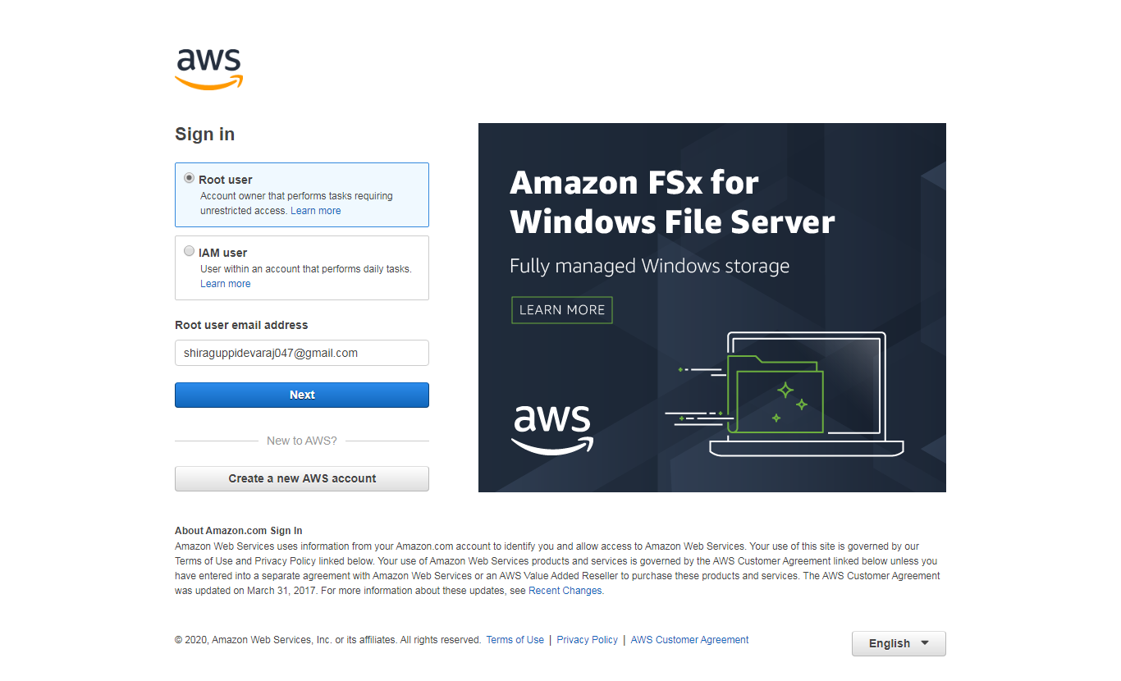

1. **EC2 dash board**

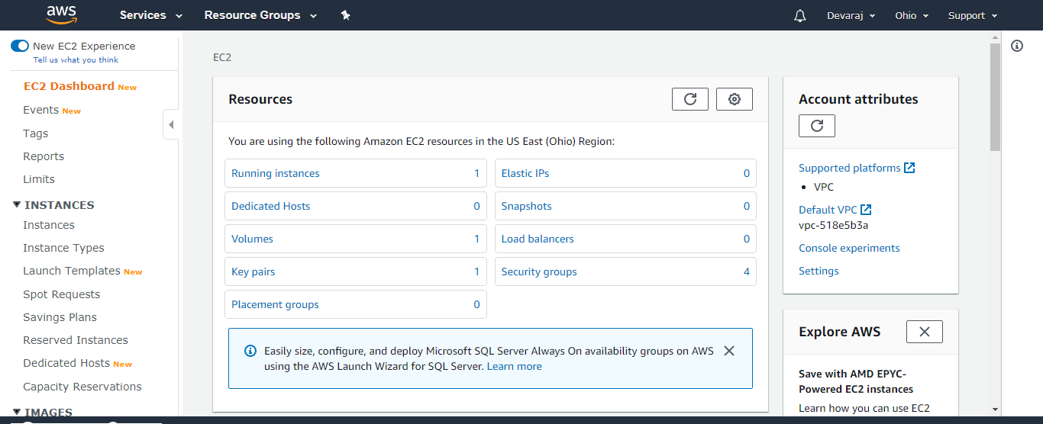

1. **S3 dash board**

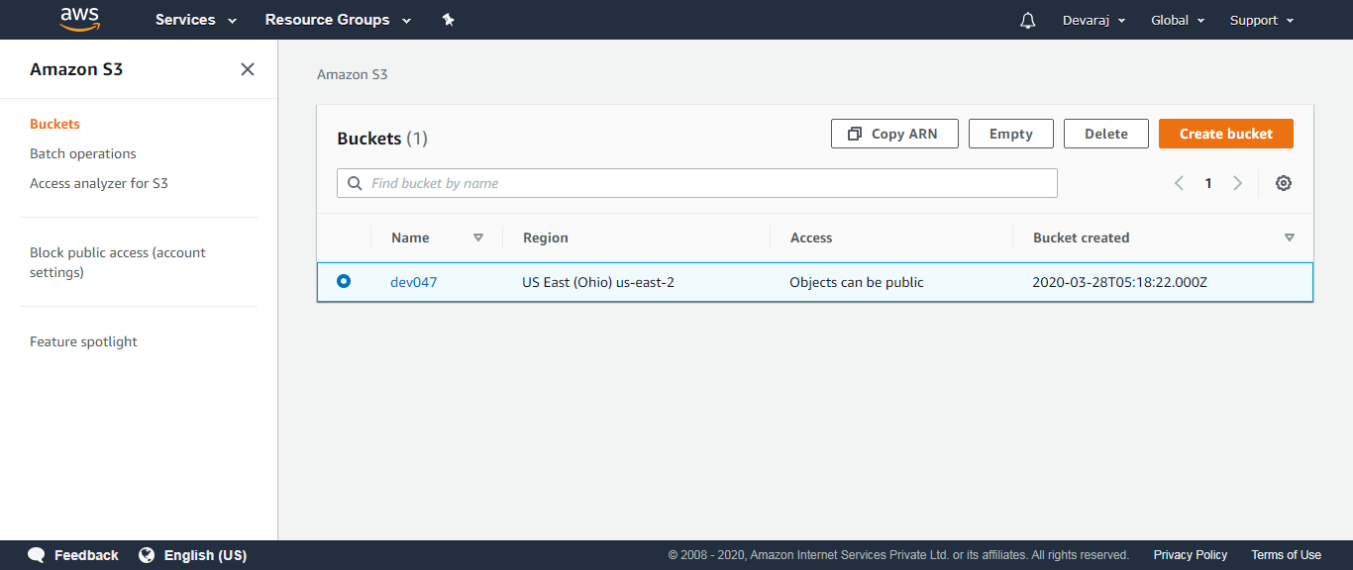

1. **Rekognition dash board**

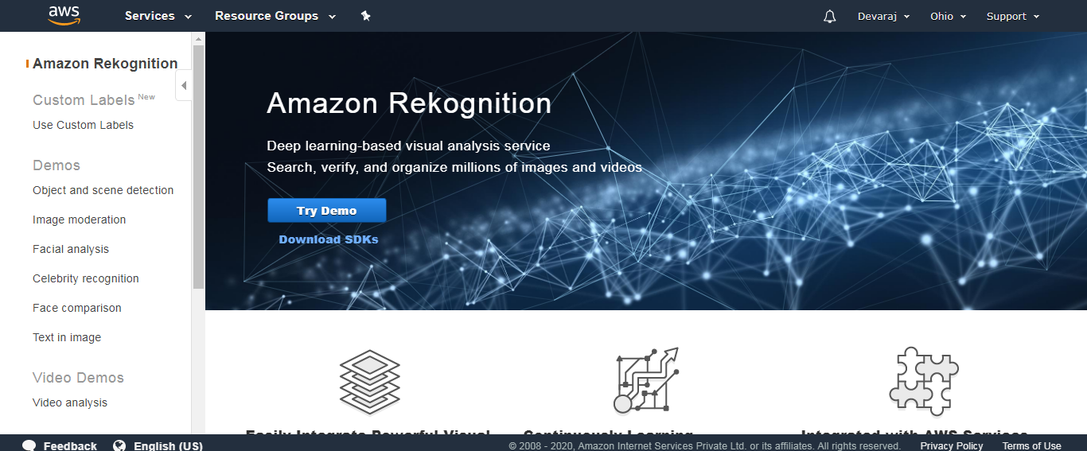

**EC2:**

1. **Choosing an AMI**

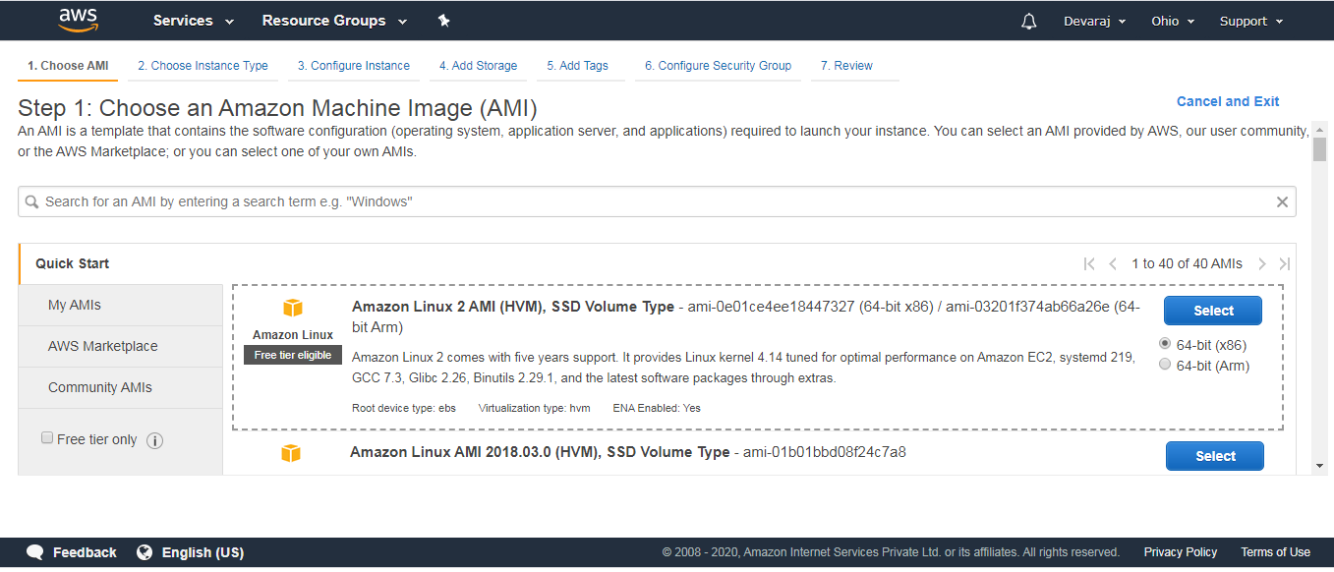

1. **Choosing an instance type**

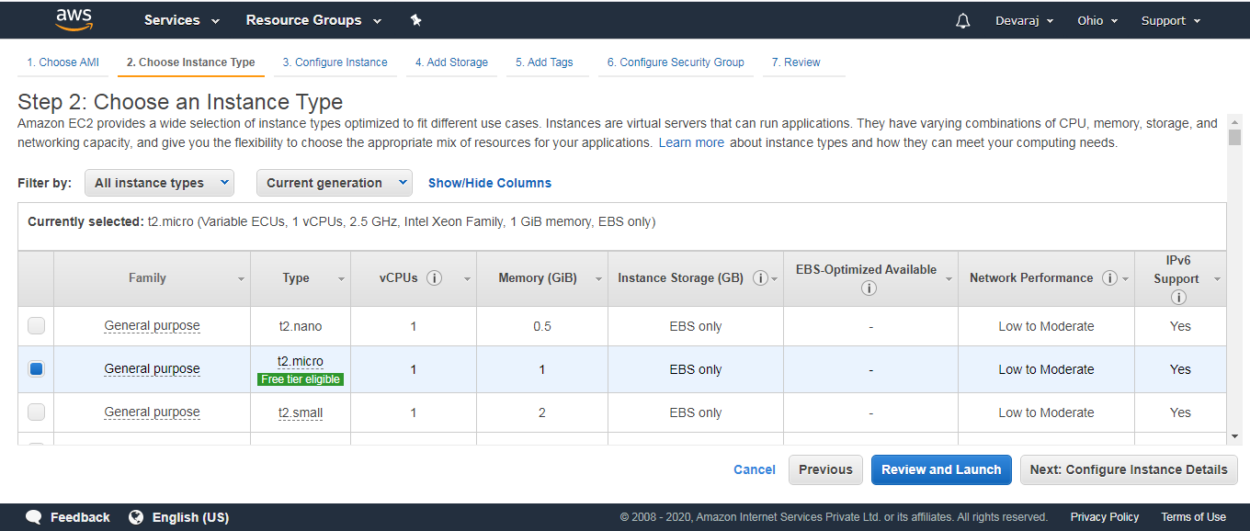

1. **Adding storage**

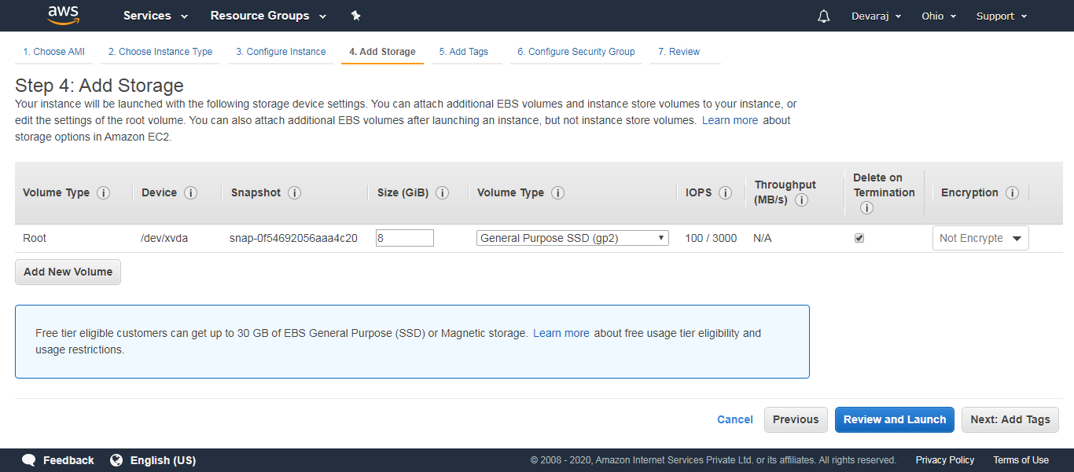

1. **Configuration security group**

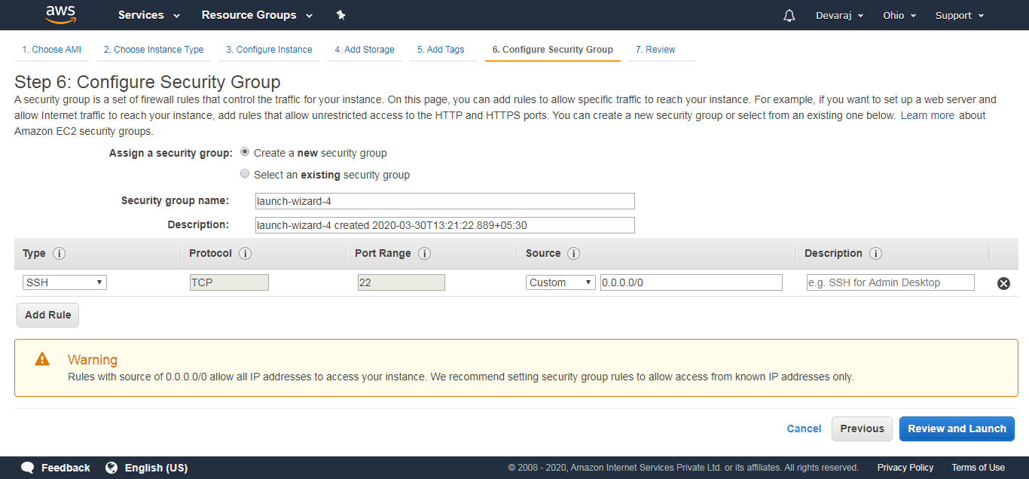

1. **Key pair download**

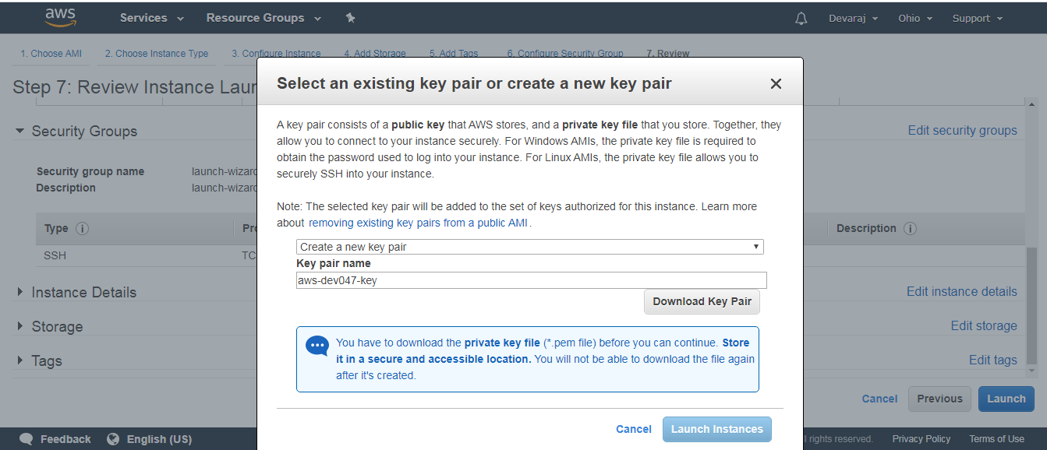

1. **Puttygen conversion from pem to ppk**

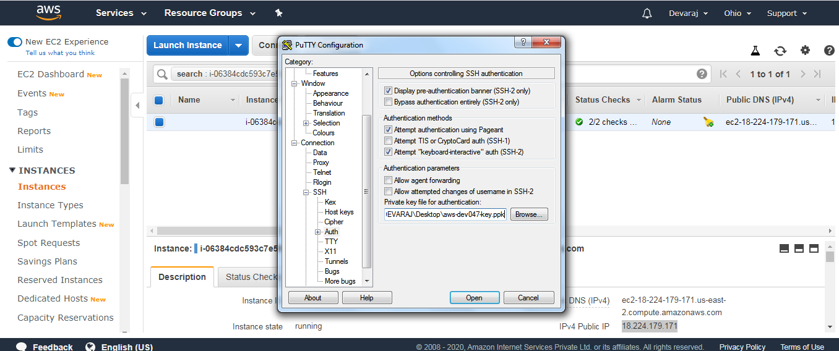

1. **Logged in EC2 black screen**

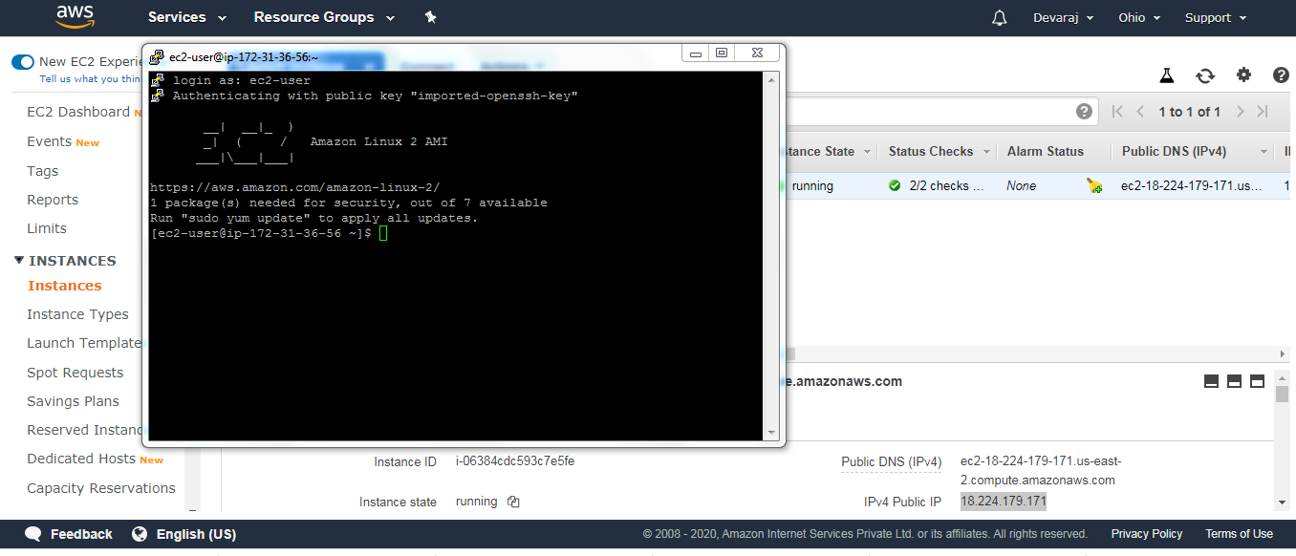

**S3:**

1. **Creating bucket**

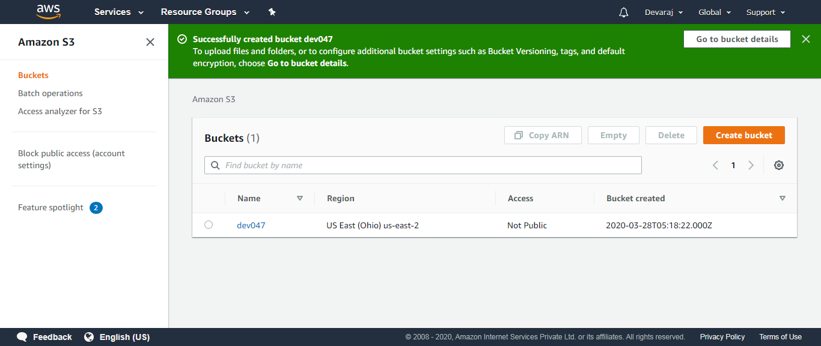

1. **Uploading an object**

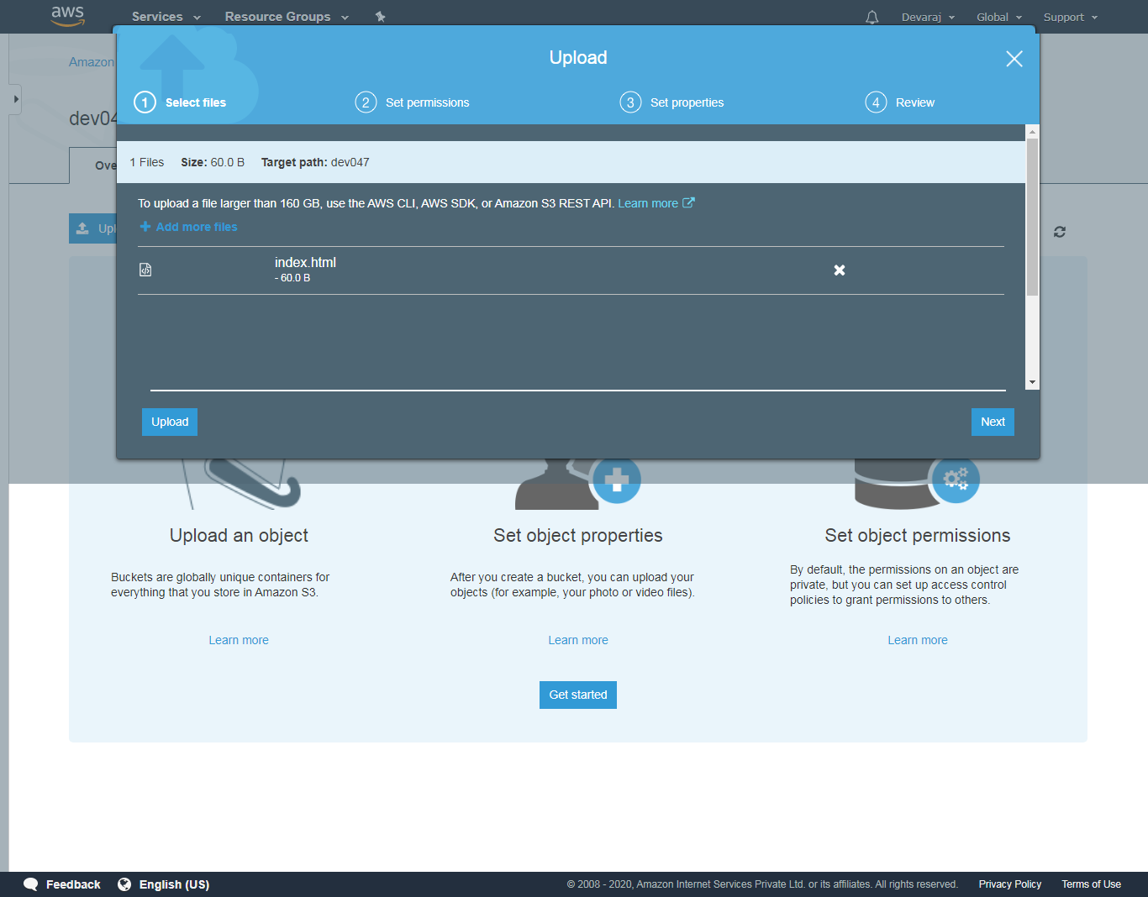

1. **Enabling static website**

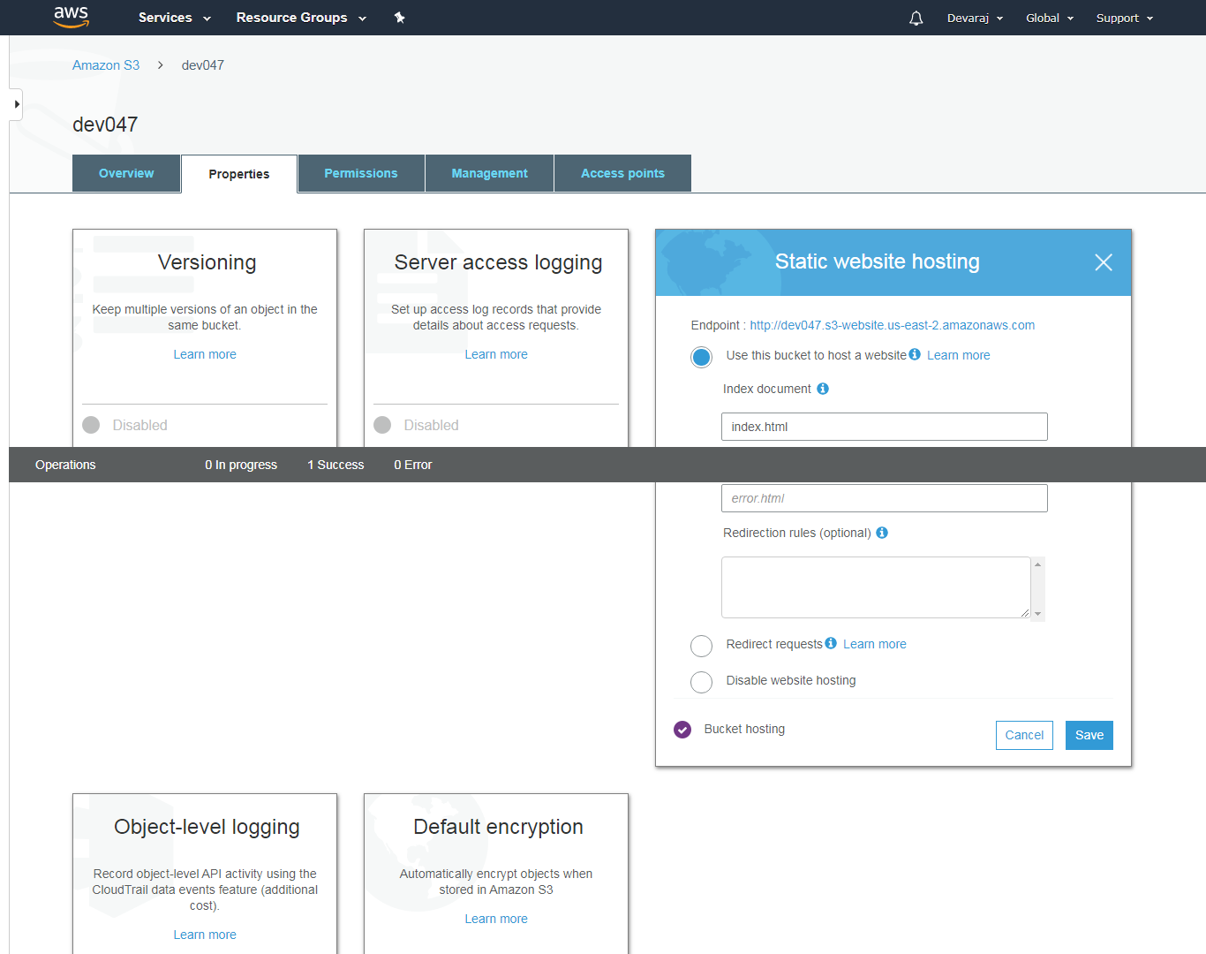

1. **Making the object public**

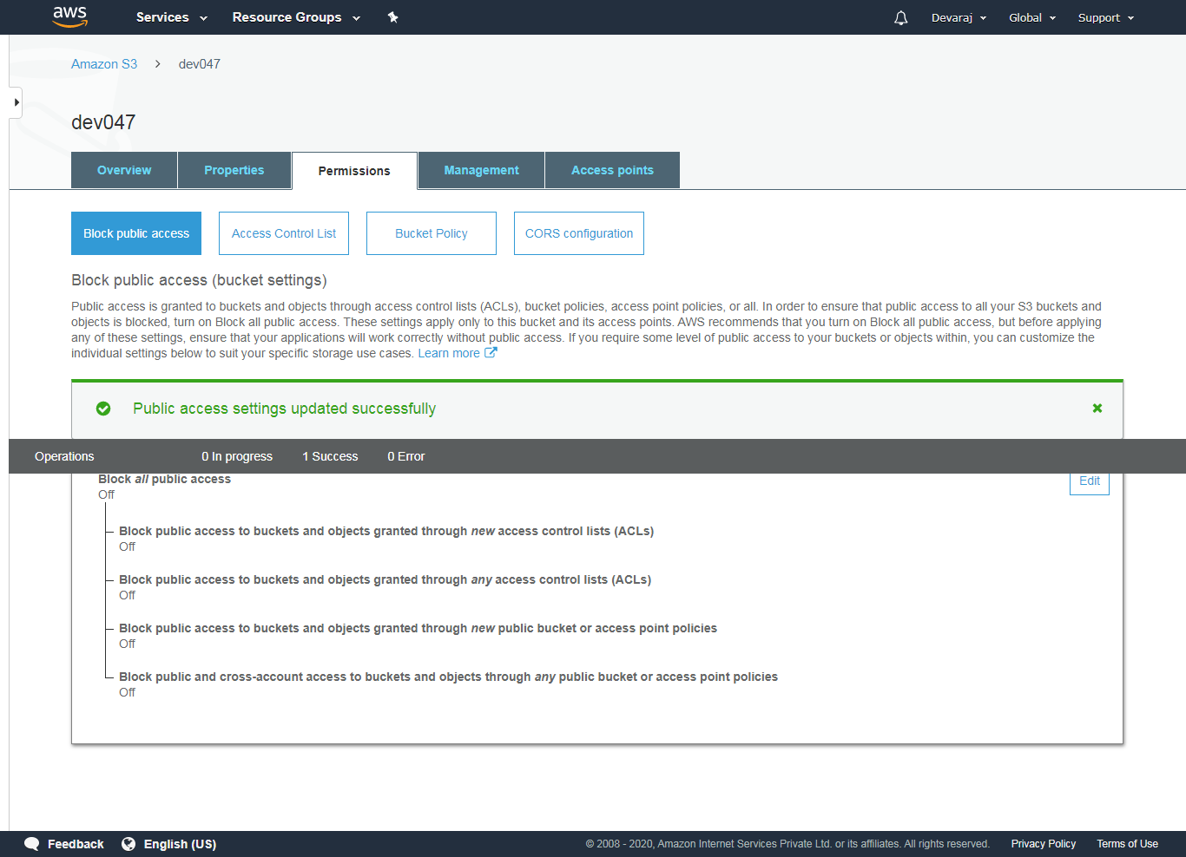

1. **Checking the S3 link on the browser**

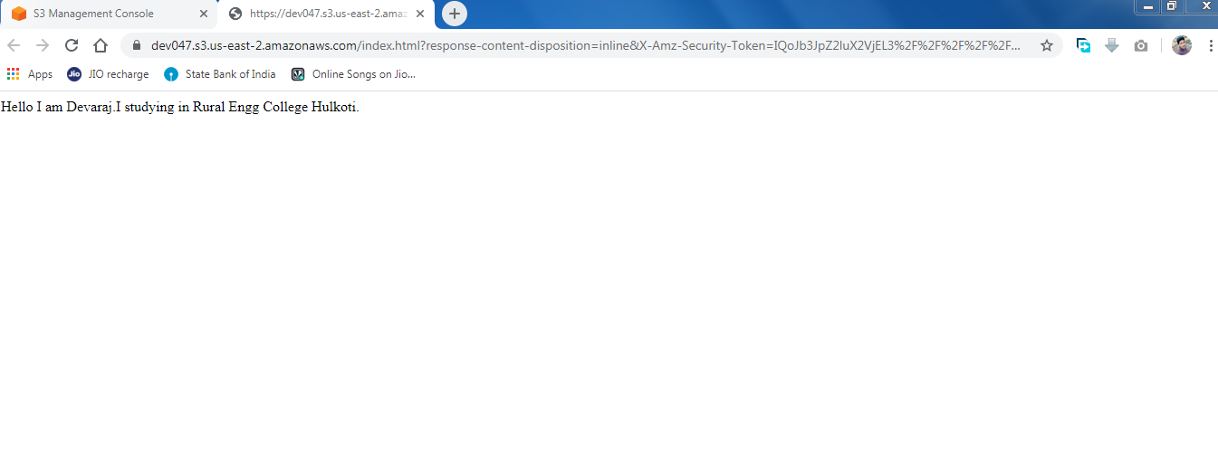

**Rekognition:**

1. **Face detect**

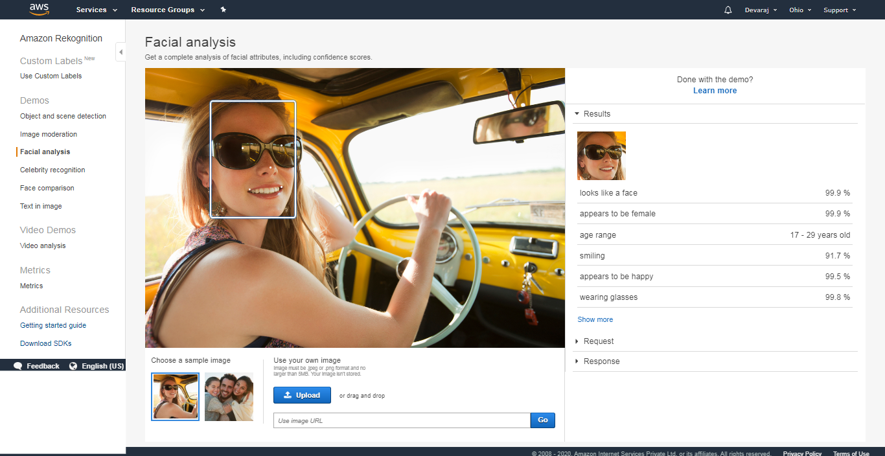

1. **Face compare**

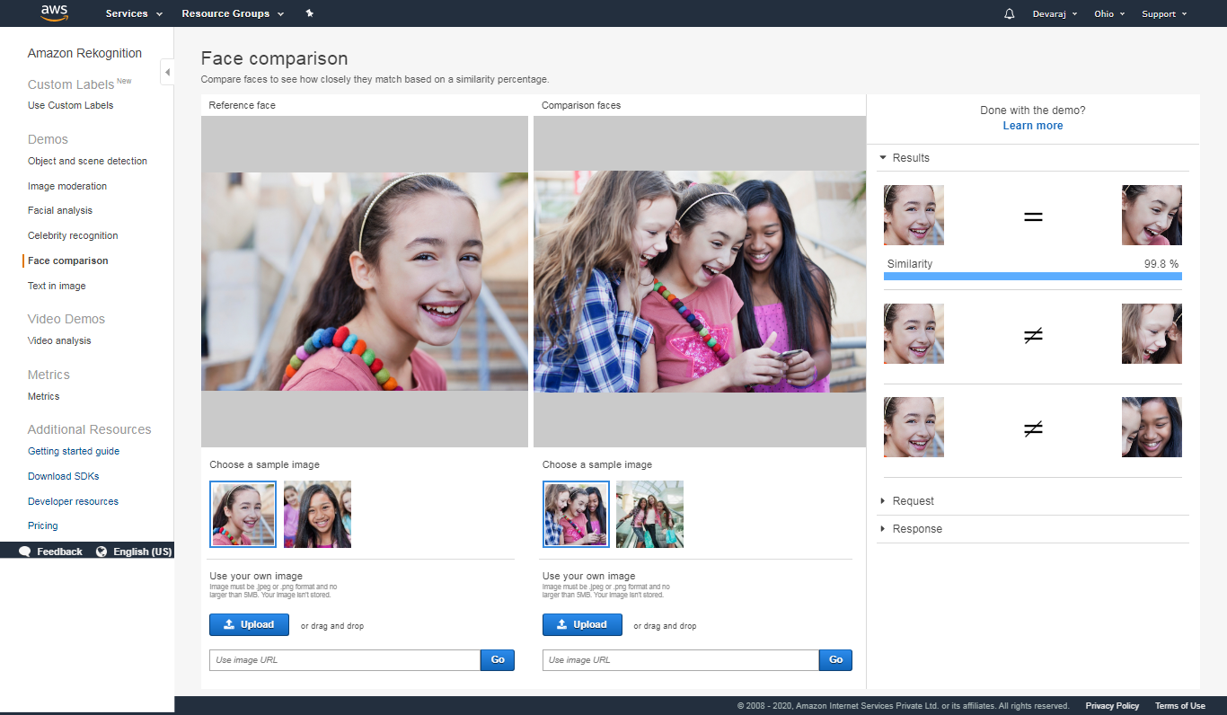

1. **Celebrity recognition**

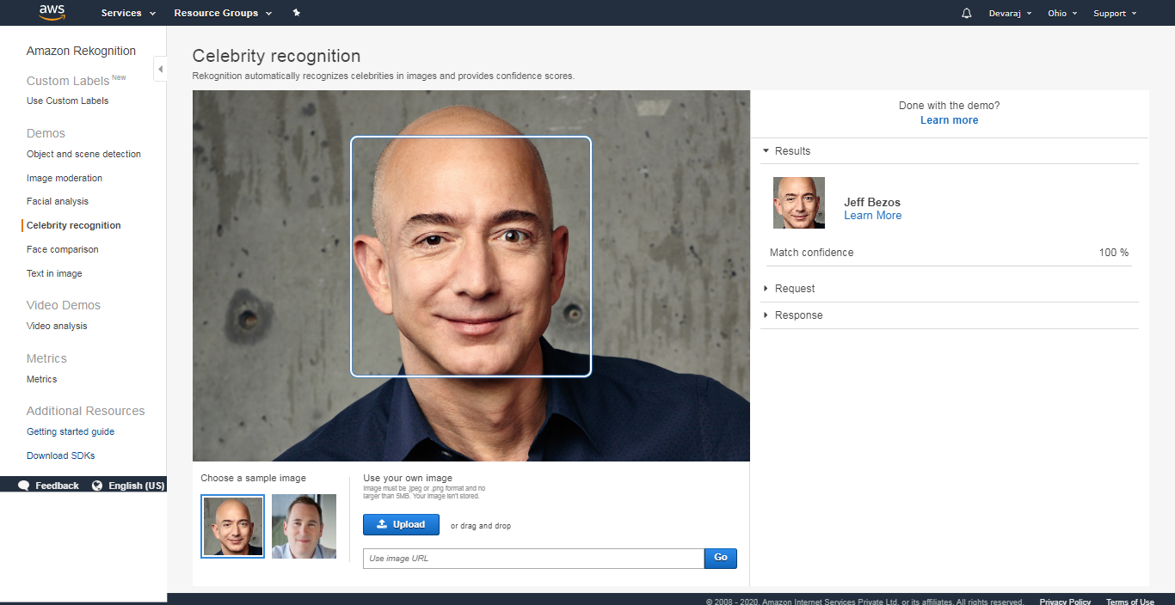

1. **Text in image**

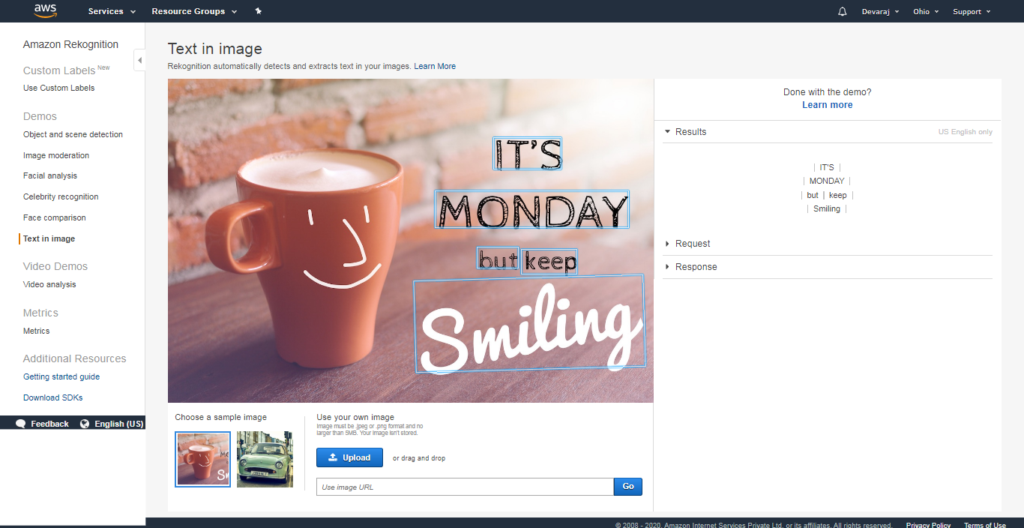

**EC2 & S3:**

1. **Installing aws-sdk**

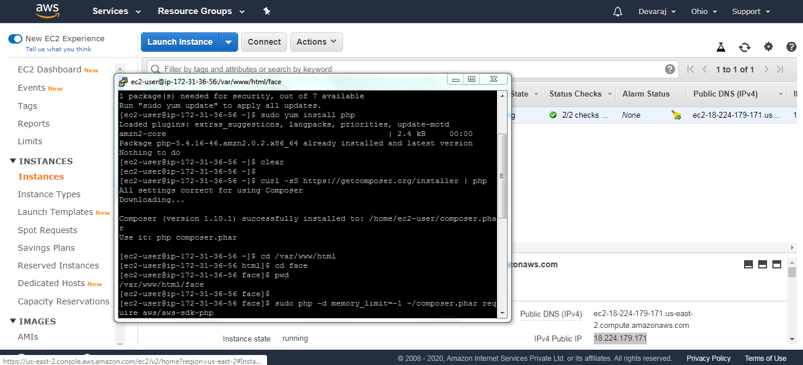

1. **Installing php**

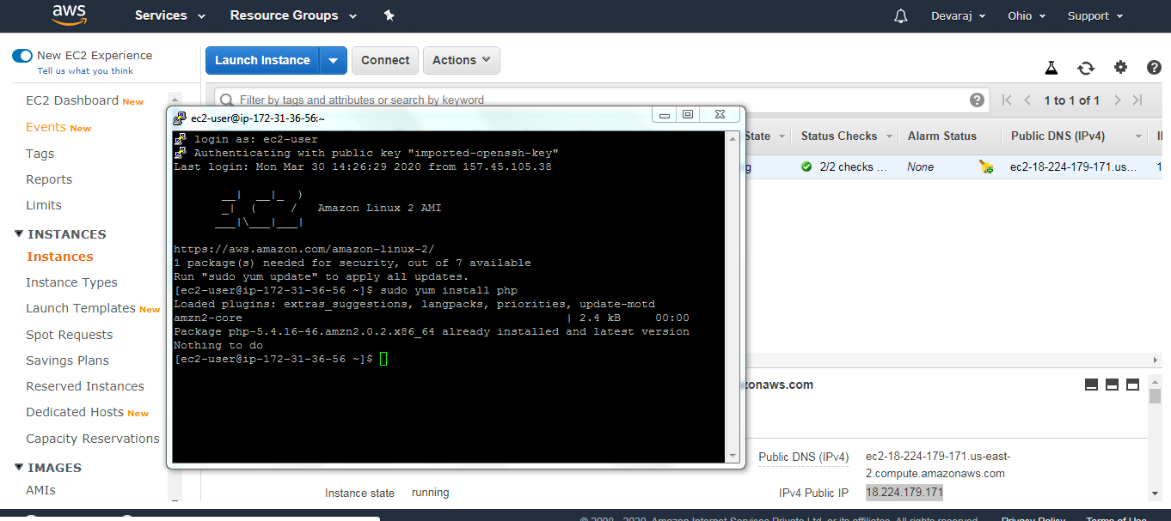

1. **Index.php file code**

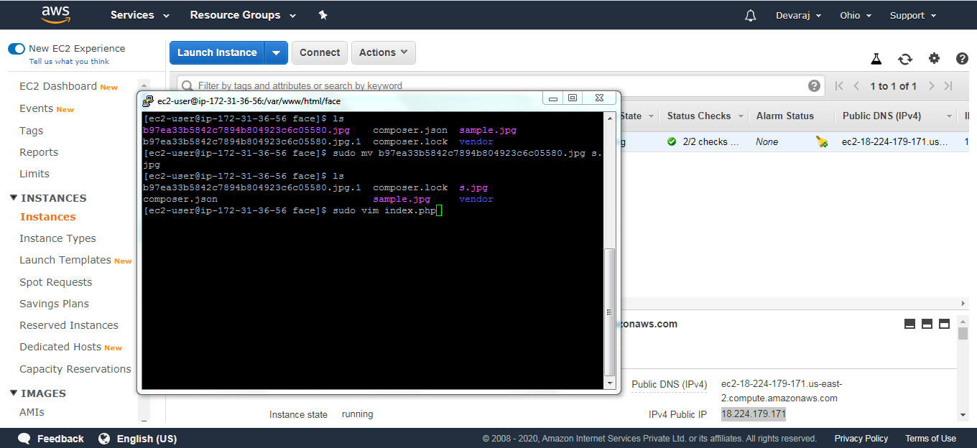

1. **Upload success**

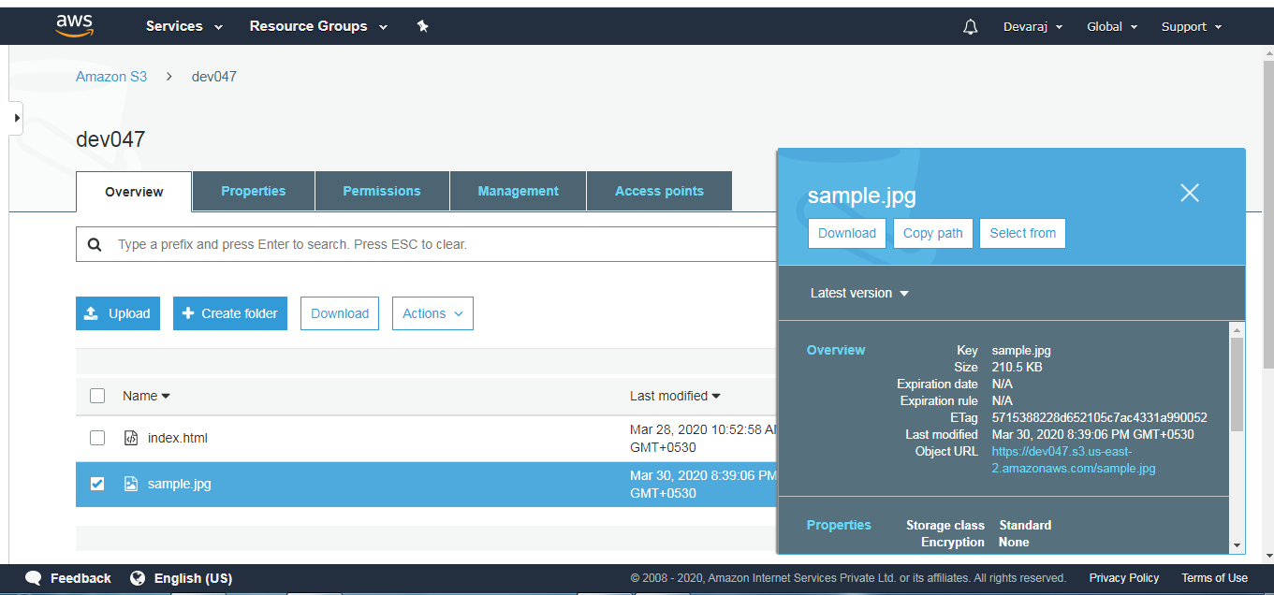

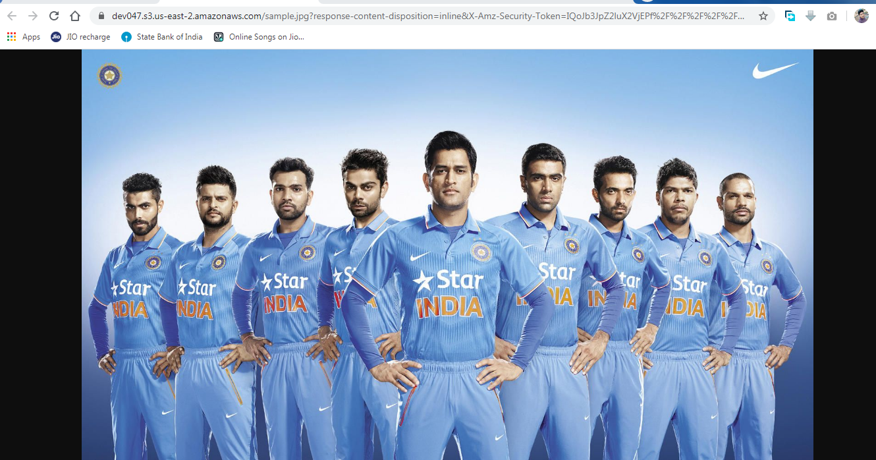

**EC2 & Rekognition:**

1. **Face detect success**